Worksheet 7

Student Name:Aryan Tomar UID:25MCI10167
Branch:MCA (AI&ML) Section/Group:1/A
Semester:2nd Date of Performance:31/03/2026
Subject Name:- DBMS LAB Subject Code: 25CAP-652

1. Aim of the Session

Implementation of JOINS in PostgreSQL

2. Software Requirements
- PostgreSQL (Database Server)
- pgAdmin
- Windows Operating System

3. Objective of the Session
- To understand different types of SQL JOINs (INNER, LEFT, RIGHT, CROSS)
- To retrieve and combine data from multiple related tables
- To identify matched and unmatched records using joins
- To apply JOIN operations in real-world database scenarios

4. Practical / Experiment Steps

Prerequisite Understanding
- Basic knowledge of DBMS concepts (tables, rows, columns)
- Understanding of SQL commands (SELECT, WHERE, etc.)
- Knowledge of primary key and foreign key relationships
- Basic idea of relational databases and table linking

5. Procedure of the Practical

(i) Start the system and log in to the computer.

(ii) Open PostgreSQL software.

iii) Create and select the database.

Create database Practical7;

(iv) Create table using DDL command.

CREATE TABLE departments (

department_id INT PRIMARY KEY,

department_name VARCHAR(50)

);

CREATE TABLE students (

student_id INT PRIMARY KEY,

name VARCHAR(50),

department_id INT,

FOREIGN KEY (department_id) REFERENCES departments(department_id)

);

CREATE TABLE courses (

course_id INT PRIMARY KEY,

course_name VARCHAR(50)

);

CREATE TABLE enrollments (

student_id INT,

course_id INT,

PRIMARY KEY (student_id, course_id),

FOREIGN KEY (student_id) REFERENCES students(student_id),

FOREIGN KEY (course_id) REFERENCES courses(course_id)

);

(v) Insert records into the table.

INSERT INTO departments VALUES

(1, 'Computer Science'),

(2, 'Mechanical'),

(3, 'Electrical');

INSERT INTO students VALUES

(1, 'Aryan', 1),

(2, 'Rohit', 2),

(3, 'Priya', 1),

(4, 'Simran', 3),

(5, 'Karan', NULL);

INSERT INTO courses VALUES

(101, 'DBMS'),

(102, 'OS'),

(103, 'Maths'),

(104, 'Physics');

INSERT INTO enrollments VALUES

(1, 101),

(1, 102),

(2, 103),

(3, 101);

(vi) Display all records.

select * from students;

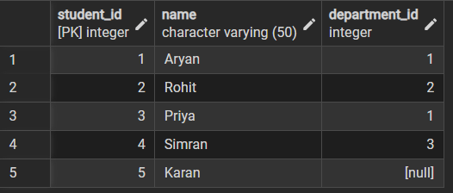

select * from department;

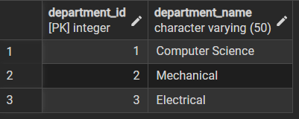

select * from courses;

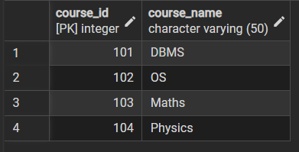

select * from enrollments;

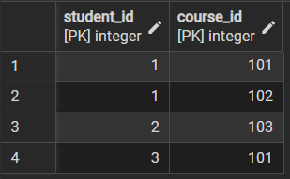

Step 1: Write queries to list students with their enrolled courses (INNER JOIN).
select
s.student_id,s.name,c.course_name
from students s
left join enrollments e on
e.student_id=e.student_id
left join courses c on
e.course_id=c.course_id;

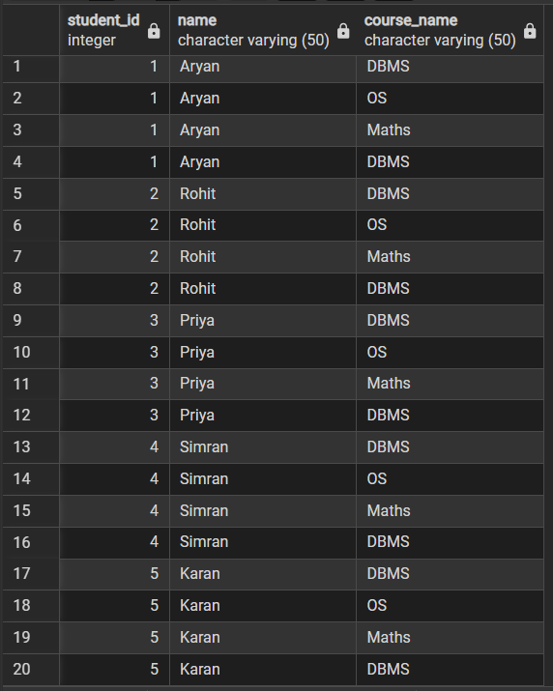

Step 2: Find students not enrolled in any course (LEFT JOIN).
select
s.student_id,s.name
from
students s
left join enrollments e on
s.student_id =e.student_id
where e.student_id is null;
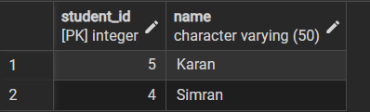
Step 3: Display all courses with or without enrolled students (RIGHT JOIN).
SELECT c.course_id, c.course_name, s.name
FROM courses c
LEFT JOIN enrollments e ON c.course_id = e.course_id
LEFT JOIN students s ON e.student_id = s.student_id;
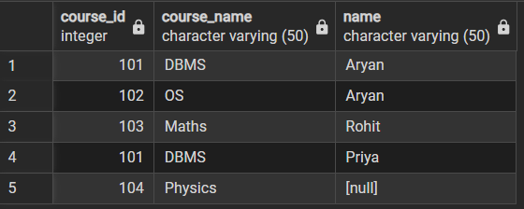

Step 4: Show students with department info using SELF JOIN or multiple joins.
SELECT s.student_id, s.name, d.department_name
FROM students s
LEFT JOIN departments d ON s.department_id = d.department_id

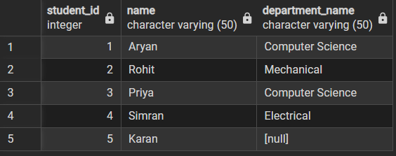

Step 5: Display all possible student-course combinations (CROSS JOIN). (Oracle, SAP, IBM, Microsoft)
SELECT s.name, c.course_name
FROM students s
CROSS JOIN courses c;

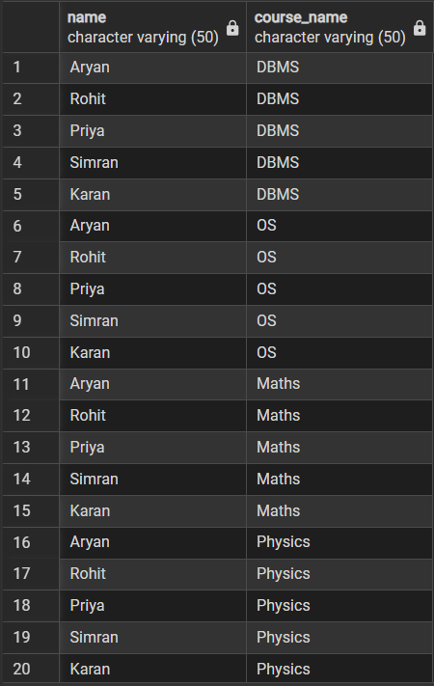

6. I/O Analysis (Input / Output)
Input:
- Students table (student_id, name, department_id)
- Courses table (course_id, course_name)
- Enrollments table (student_id, course_id)
- Departments table (department_id, department_name)
- Relationships using primary key and foreign key
Output:
- Students with their enrolled courses
- Students not enrolled in any course
- All courses with or without students
- Students with department details
- All possible student-course combinations
7. Learning Outcomes
- Understanding different types of SQL JOINs (INNER, LEFT, RIGHT, CROSS)
- Ability to combine data from multiple related tables
- Skill to identify matched and unmatched records using joins
- Improved query writing and data retrieval skills
- Ability to apply JOIN concepts in real-world database problems

